**Small Business Network Design 3 switches**

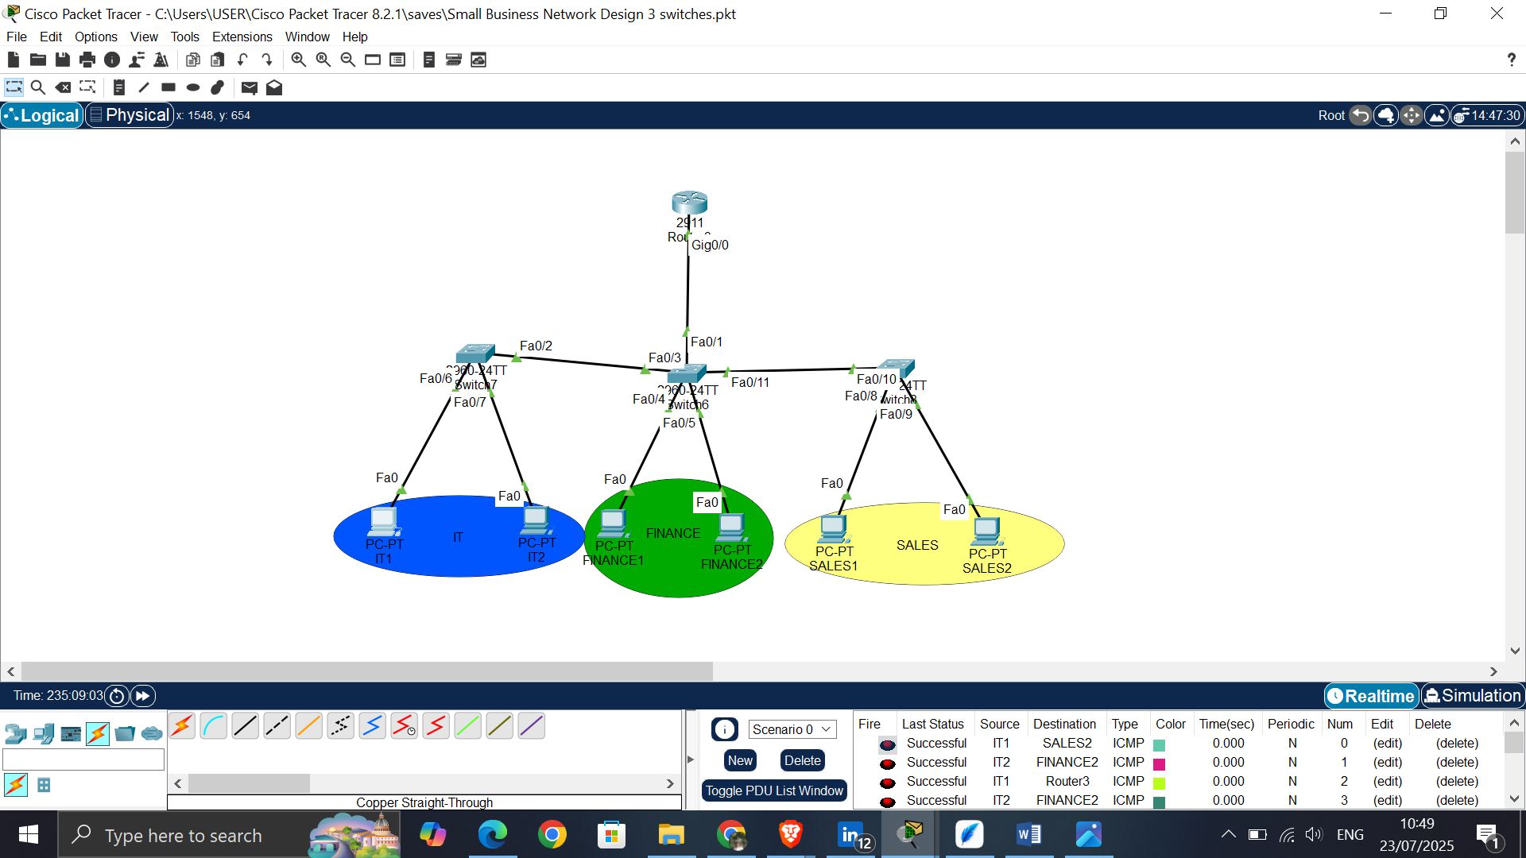

3 departments: IT, Finance, and Sales

1. Add Network Devices and Identification with color codes

* 3 switches 2960
* 1 router 2911
* Pc(6)

1. Connect Network Devices with copper straight-through cable.
2. Assign IP Addresses and Default gateways
3. Determine IP Address Class and Subnetting

* A class C IP Address (Usually preferred for medium to small sized networks) and it ranges from 192.0.0.0 to 223.255.255.255.
* **VLAN 10 (Finance)**: 192.168.10.0/24
* **VLAN 20 (IT)**: 192.168.20.0/24
* **VLAN 30 (Sales)**: 192.168.30.0/24

1. Configure VLANs on switches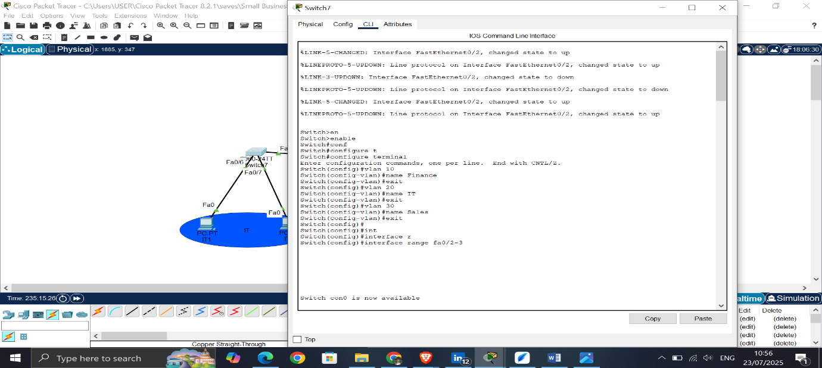

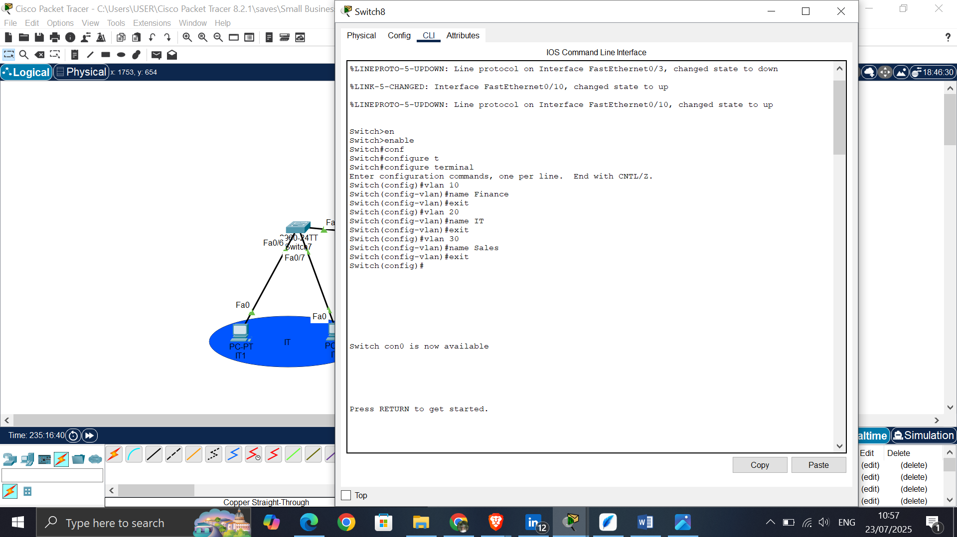

1. Assign Ports for each VLAN

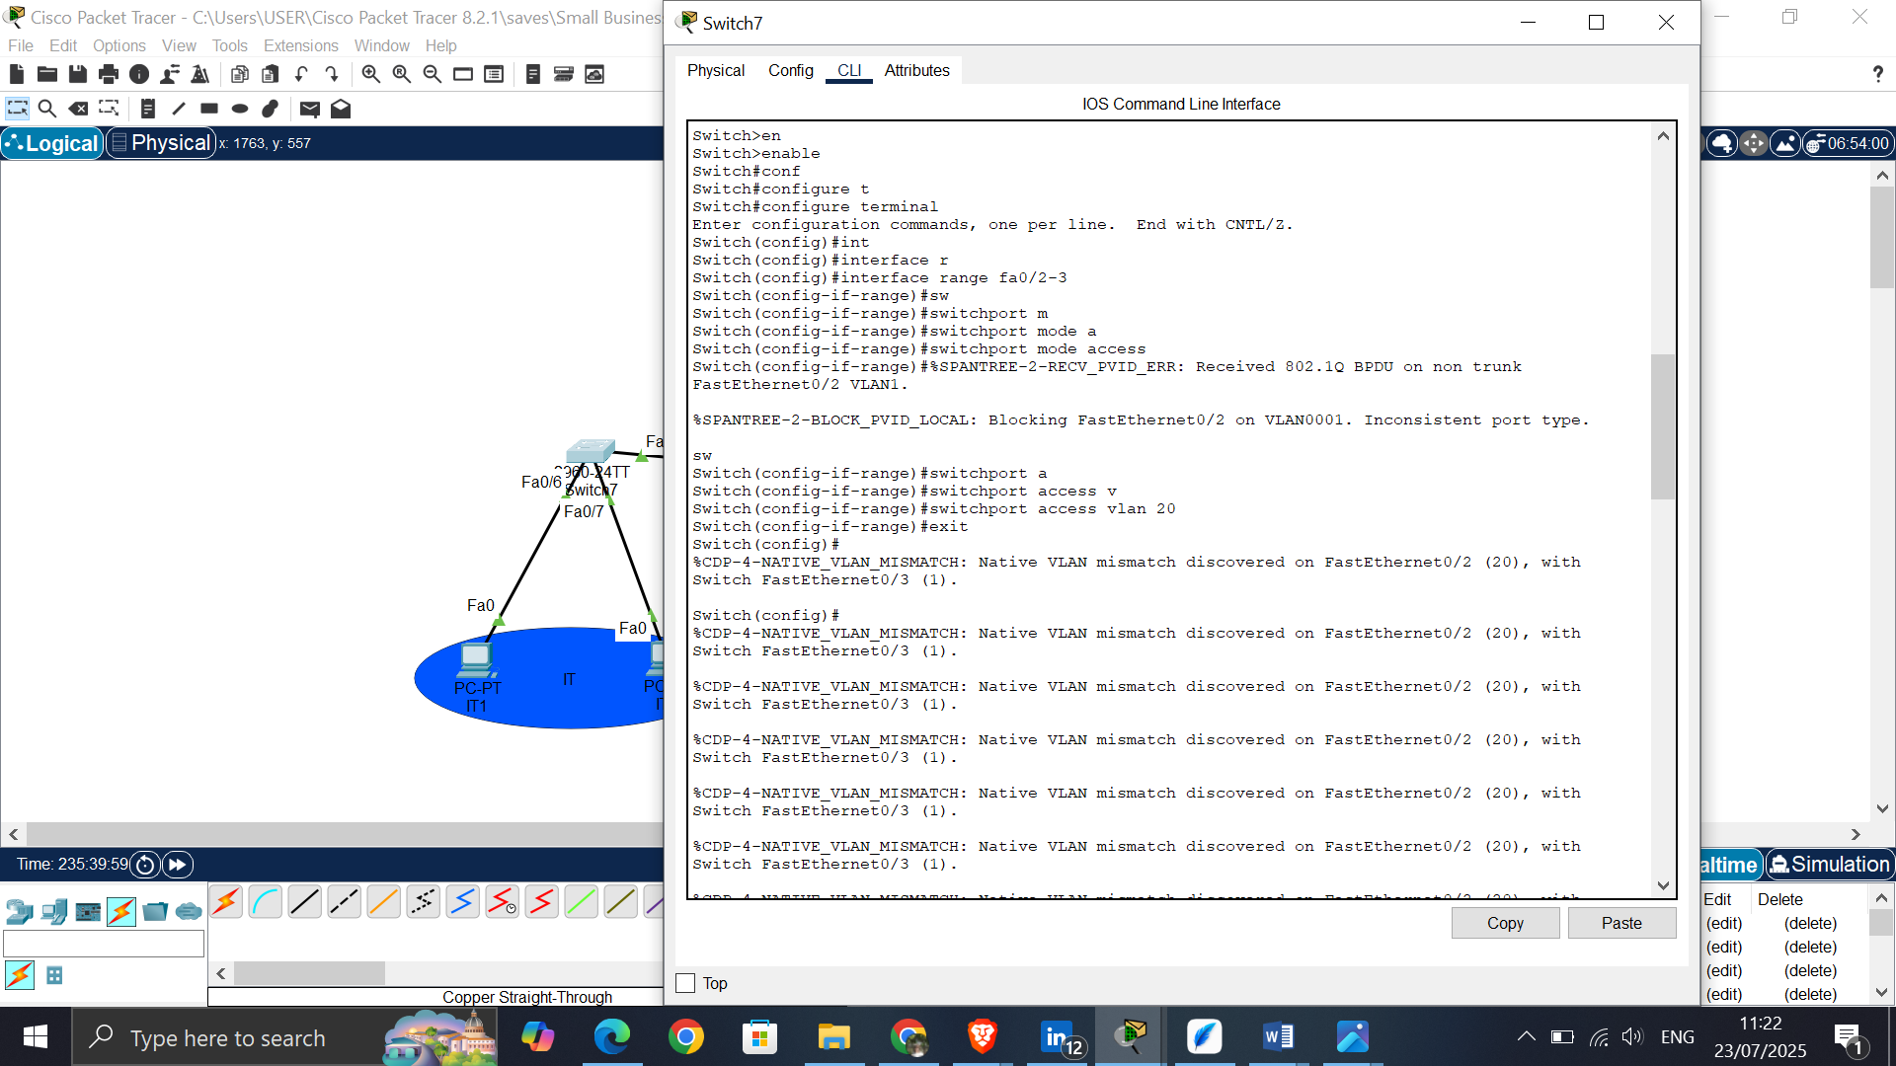

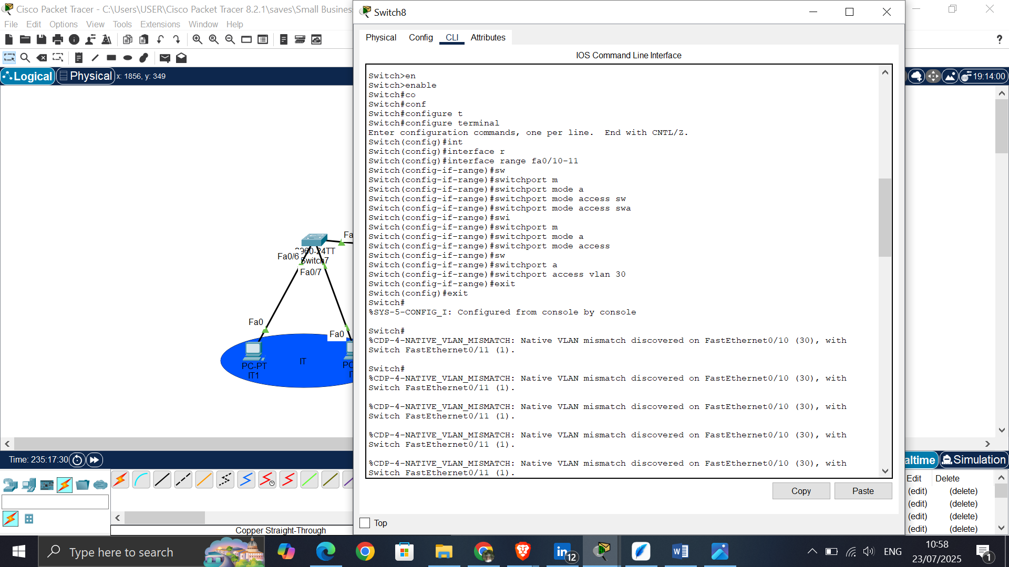

1. Configure Trunk Port on Switch

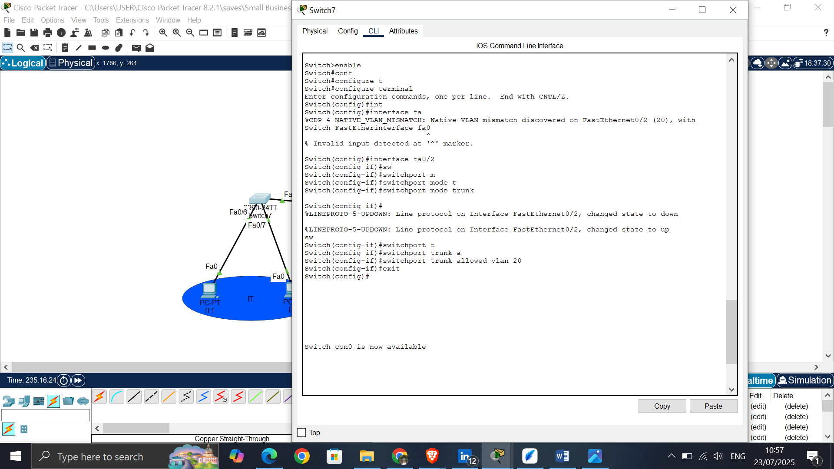

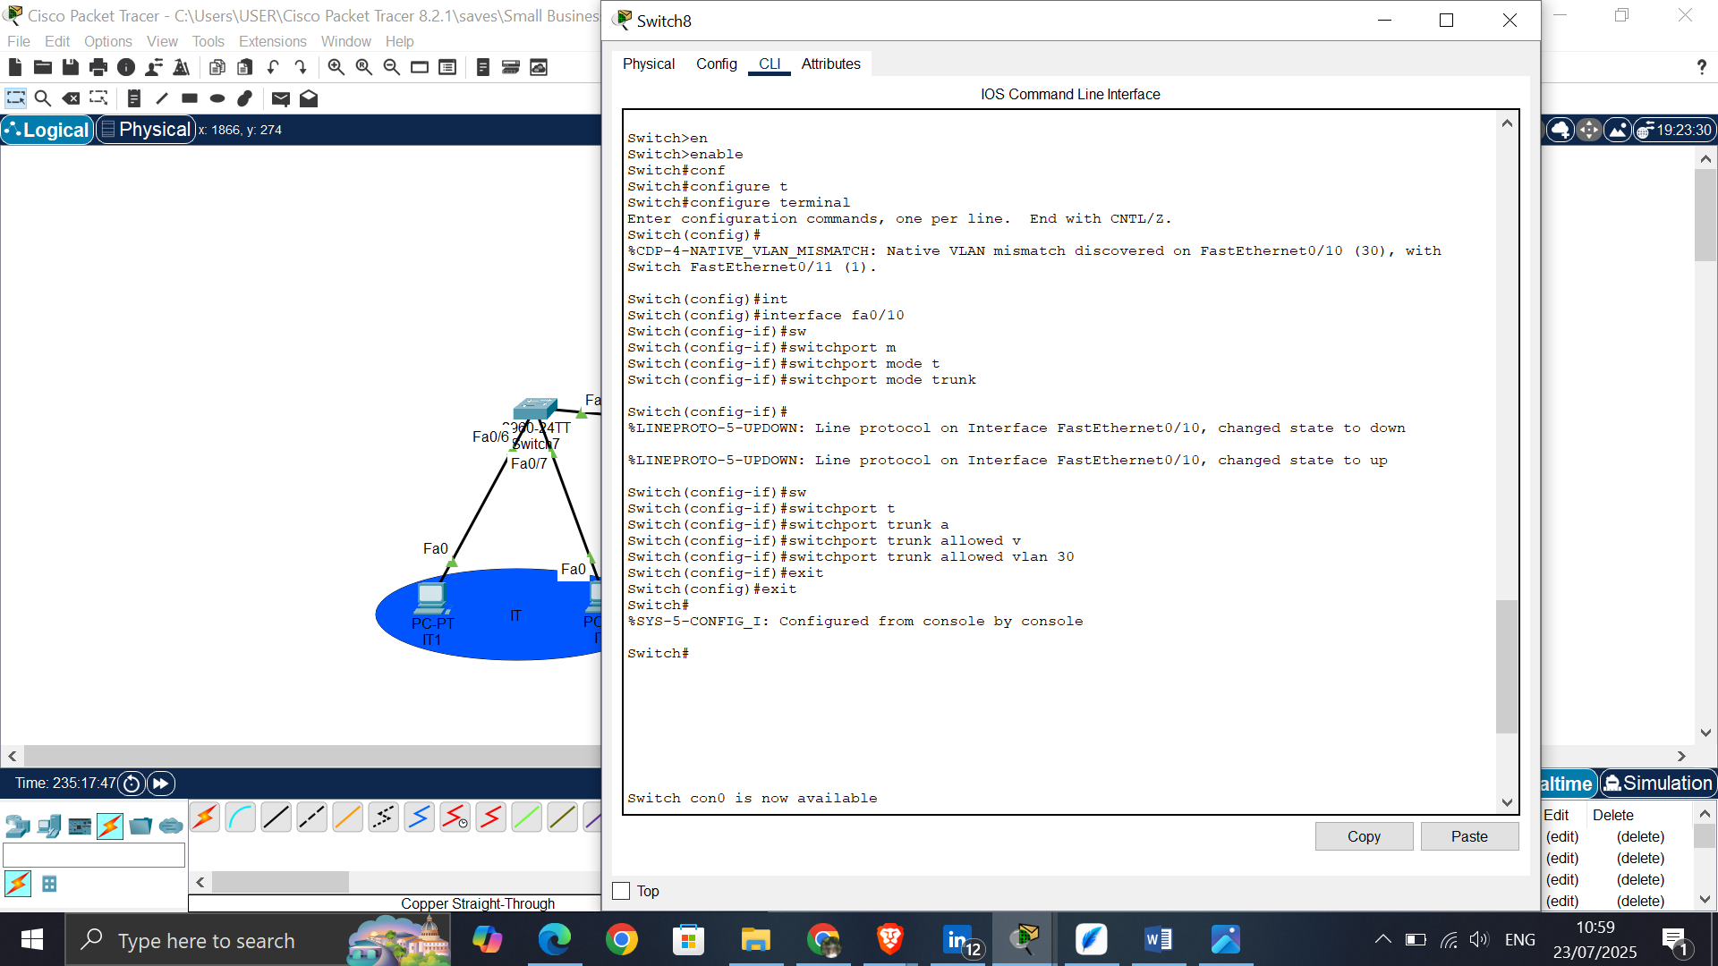

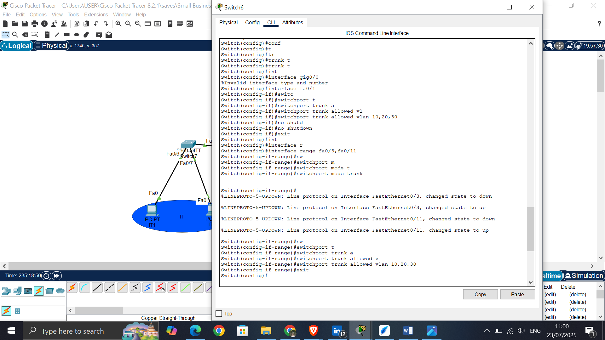

1. Configure Inter-VLAN Routing on the Router

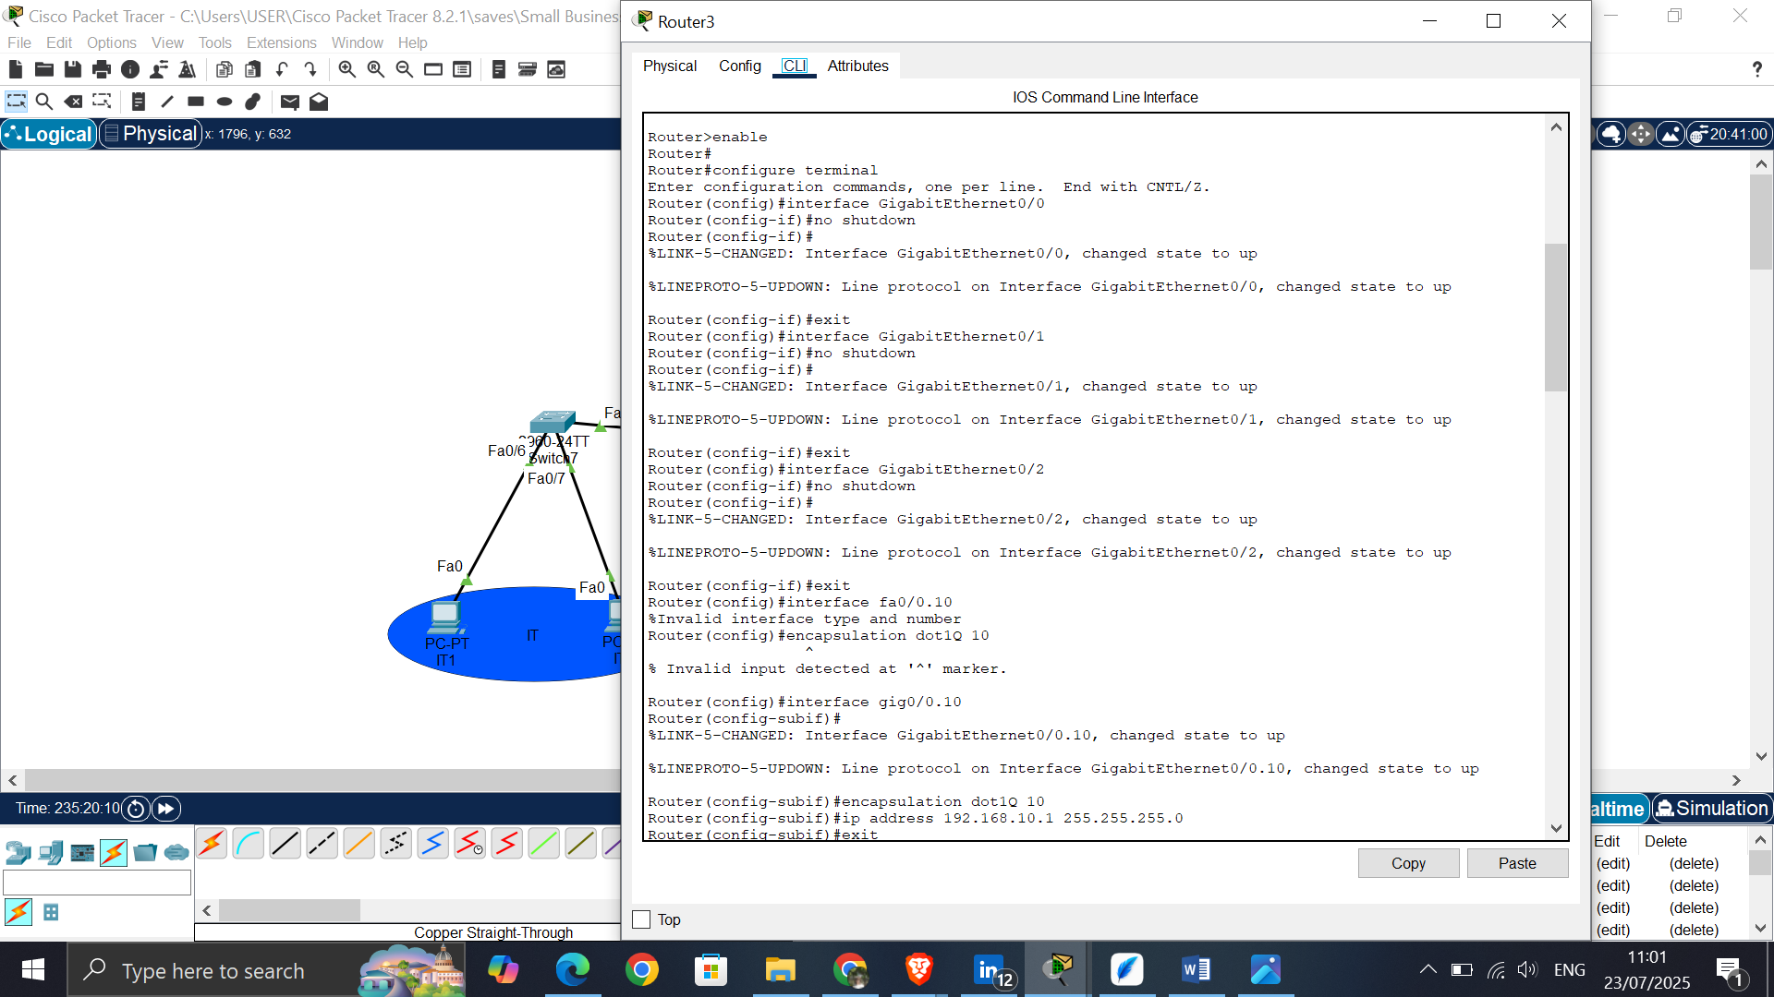

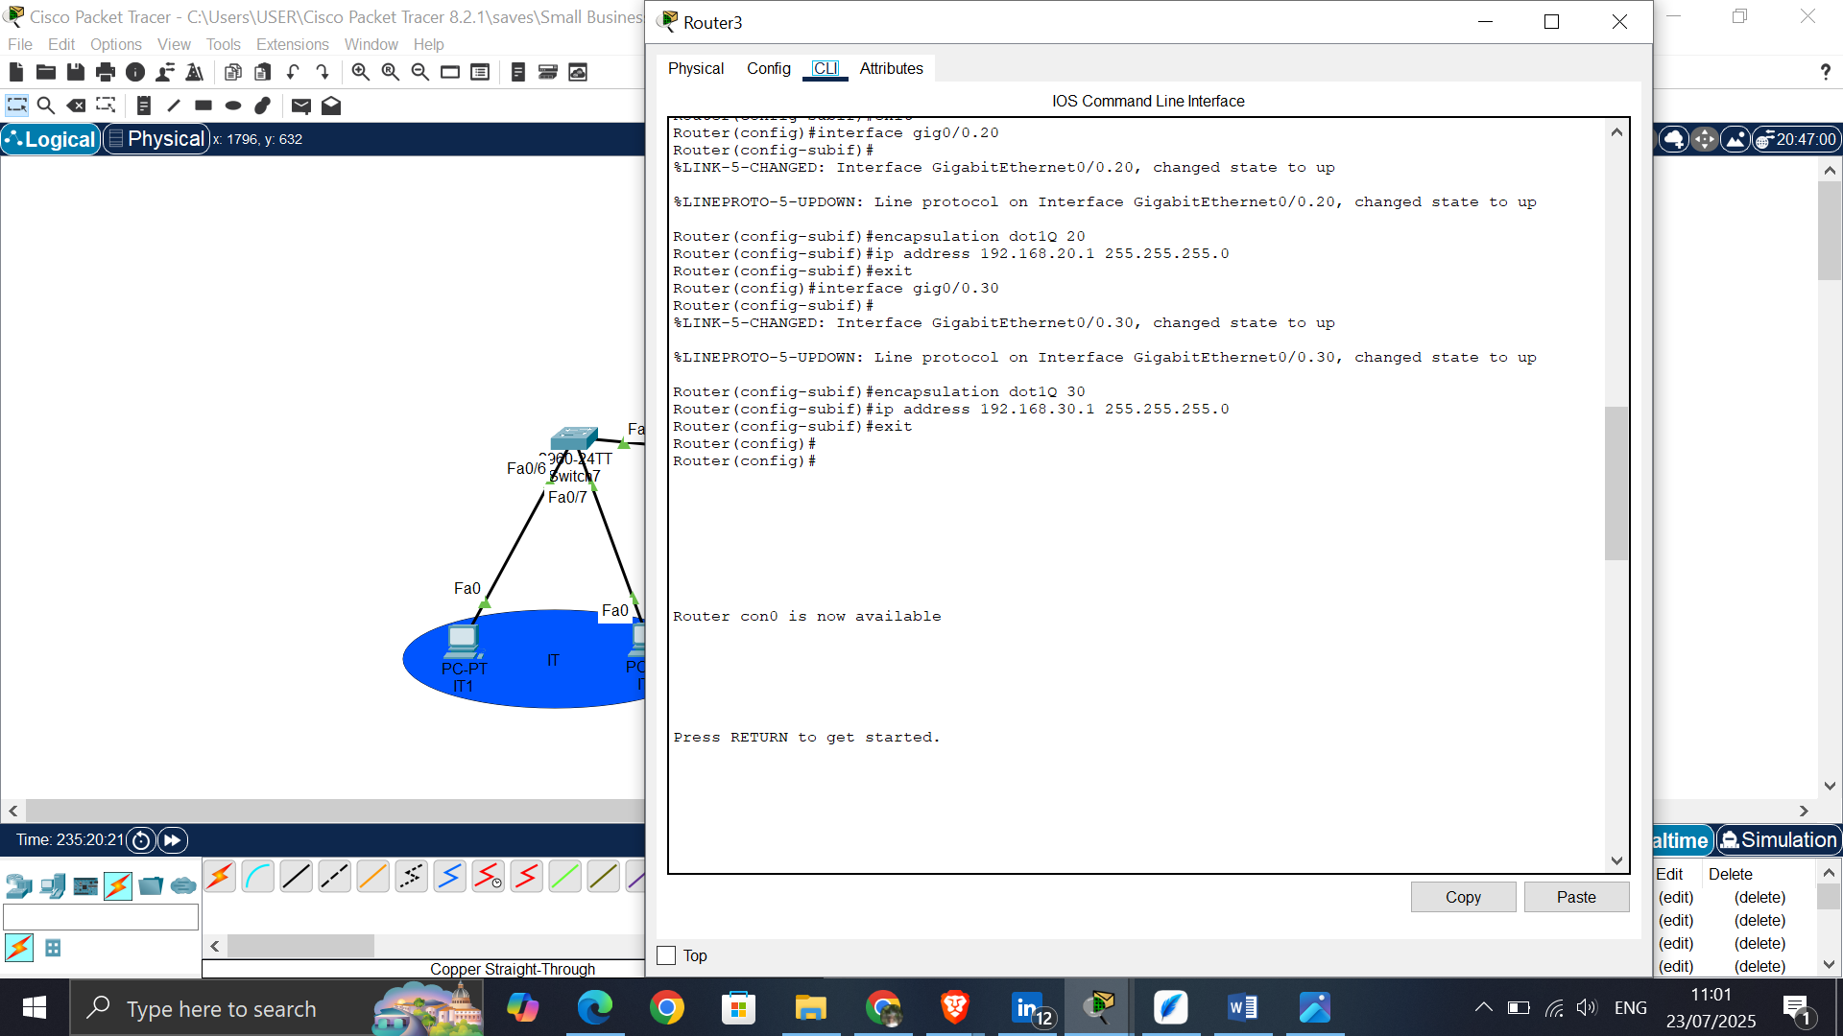

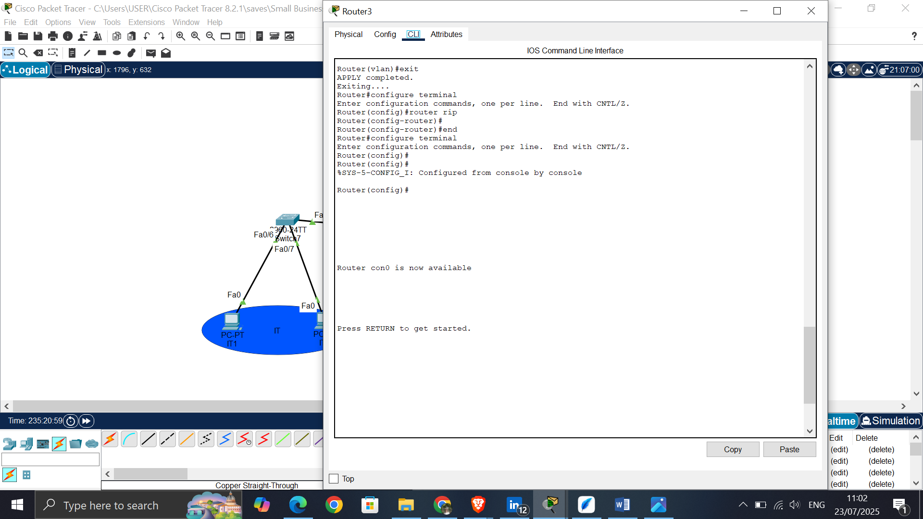

1. Verify Connectivity by pinging and entering simulation mode.

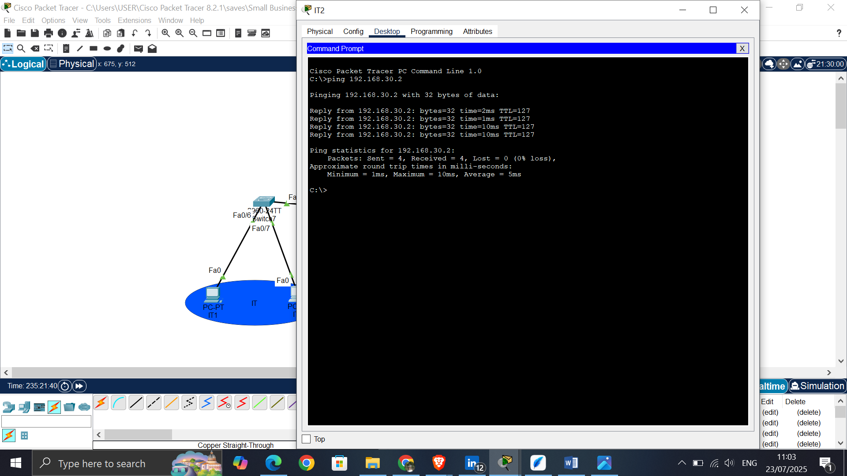

Worked by:Erinalda Loshi